

Semester 1 Examination, 2016

Question/Answer Booklet

MATHEMATICS

SOLUTIONS
METHODS
UNIT 3

Section Two:

Calculator-assumed

Student Number: In figures

In words

Your name

Time allowed for this section
Reading time before commencing work: ten minutes
Working time for section: one hundred minutes

Materials required/recommended for this section
To be provided by the supervisor
This Question/Answer Booklet
Formula Sheet (retained from Section One)

To be provided by the candidate
Standard items: pens (blue/black preferred), pencils (including coloured), sharpener, correction fluid/tape, eraser, ruler, highlighters

Special items: drawing instruments, templates, notes on two unfolded sheets of A4 paper, and up to three calculators approved for use in the WACE examinations

Important note to candidates
No other items may be taken into the examination room. It is your responsibility to ensure that you do not have any unauthorised notes or other items of a non-personal nature in the examination room. If you have any unauthorised material with you, hand it to the supervisor before reading any further.

Structure of this paper

Section | Number of questions available | Number of questions to be answered | Working  time (minutes) | Marks available | Percentage of exam
Section One:  Calculator-free | 8 | 8 | 50 | 48 | 35
Section Two:  Calculator-assumed | 13 | 13 | 100 | 101 | 65
 |  |  | Total | 149 | 100

Instructions to candidates

- The rules for the conduct of examinations are detailed in the school handbook. Sitting this examination implies that you agree to abide by these rules.

- Write your answers in this Question/Answer Booklet.

- You must be careful to confine your response to the specific question asked and to follow any instructions that are specified to a particular question.

- Spare pages are included at the end of this booklet. They can be used for planning your responses and/or as additional space if required to continue an answer.
- Planning: If you use the spare pages for planning, indicate this clearly at the top of the page.
- Continuing an answer: If you need to use the space to continue an answer, indicate in the original answer space where the answer is continued, i.e. give the page number. Fill in the number of the question that you are continuing to answer at the top of the page.

- Show all your working clearly. Your working should be in sufficient detail to allow your answers to be checked readily and for marks to be awarded for reasoning. Incorrect answers given without supporting reasoning cannot be allocated any marks. For any question or part question worth more than two marks, valid working or justification is required to receive full marks. If you repeat any question, ensure that you cancel the answer you do not wish to have marked.

- It is recommended that you do not use pencil, except in diagrams.

- The Formula Sheet is not to be handed in with your Question/Answer Booklet.

Section Two: Calculator-assumed 65% (101 Marks)
This section has thirteen (13) questions. Answer all questions. Write your answers in the spaces provided.

Working time for this section is 100 minutes.

Question 9 (5 marks)
A recent news report said that it took 34 months for the population of Australia to increase from 23 to 24 million people.

(a) Assuming that the rate of growth of the population can be modelled by the equation , where P is the population of Australia at time t months, determine the value of the constant k. (3 marks)
Solution
Specific behaviours
uses growth and decay equation
substitutes correctly
solves for k

(b) Assuming the current rate of growth continues, how long will it take for the population to increase from 24 million to 25 million people? (2 marks)

Solution
Specific behaviours
sets up correct values in equation, using k to at least 3sf
solves for t

Question 10 (7 marks)
A small object is moving in a straight line with acceleration ms⁻², where t is the time in seconds and k is a constant. When the object was stationary and had a displacement of 4 metres relative to a fixed point O on the line. When the object had a velocity of 1 ms⁻¹.

(a) Determine the value of k and hence an equation for the velocity of the object at time t.
(4 marks)
Solution
Specific behaviours
antidifferentiates acceleration, adding constant
derives simultaneous equations from information
solves equations
writes velocity equation

(b) Determine the displacement of the object when . (3 marks)
Solution
Specific behaviours
antidifferentiates velocity
determines constant
evaluates displacement

Question 11 (7 marks)
It is known that 15% of Year 12 students in a large country study advanced mathematics.

A random sample of n students is selected from all Year 12's in this country, and the random variable X is the number of those in the sample who study advanced mathematics.

(a) Describe the distribution of X. (2 marks)
Solution
- binomial distribution with n trials and .
Specific behaviours
states binomial distribution
states parameters of binomial distribution

(b) If , determine the probability that

(i) three of the students in the sample study advanced mathematics. (1 mark)
Solution
Specific behaviours
evaluates probability

(ii) more than three of the students in the sample study advanced mathematics.
(1 mark)
Solution
Specific behaviours
evaluates probability

(iii) none of the students in the sample study advanced mathematics. (1 mark)
Solution
Specific behaviours
evaluates probability

(c) If ten random samples of 22 students are selected, determine the probability that at least one of these samples has no students who study advanced mathematics. (2 marks)
Solution
Specific behaviours
states binomial distribution with parameters
evaluates probability

Question 12 (8 marks)
The height of grain in a silo, initially 0.4 m, is increasing at a rate given by for , where h is the height of grain in metres and t is in hours.

(a) At what time is the height of grain rising the fastest? (2 marks)
Solution
Specific behaviours
differentiates rate of change
solves derivative equal to zero to obtain time.

(b) Determine the height of grain in the silo after 11 hours. (3 marks)
Solution
Specific behaviours
shows integral of rate of change
evaluates integral to obtain change in height
adds initial height

(c) Calculate the time taken for the grain to reach a height of 4.45 m. (3 marks)
Solution
Specific behaviours
determines change in height
evaluates integral using constant
solves equation, ignoring solutions outside domain

Question 13 (6 marks)
The shaded region on the graph below is enclosed by the curves and .

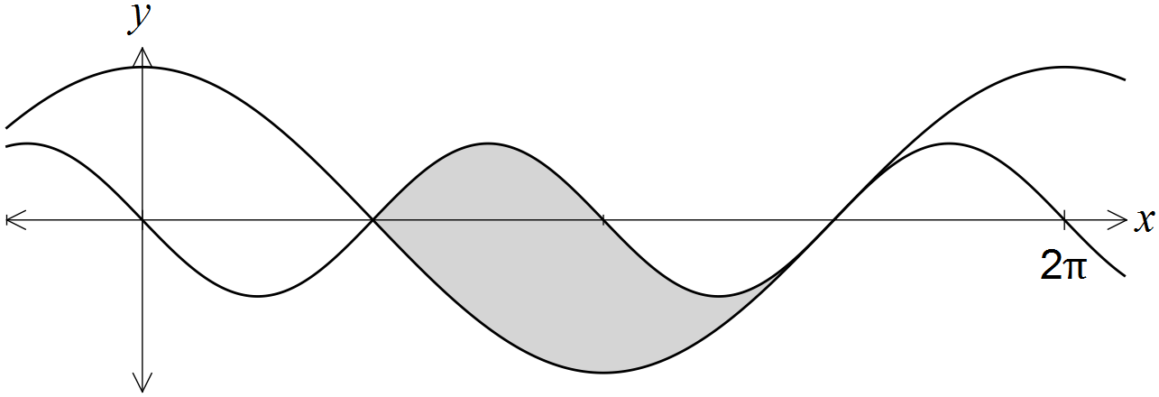

Show that the area of the region is 4 square units.
Solution
Specific behaviours
equates equations
solves equations over interval (may choose to use CAS)
writes integral
shows antiderivative
substitutes limits
evaluates integral

Question 14 (14 marks)

(a) Determine the mean of a Bernoulli distribution with variance of 0.24. (3 marks)
Solution
Specific behaviours
writes variance equation
solves equation
states both values of p are possible means

(b) A Bernoulli trial, with probability of success p, is repeated n times. The resulting distribution of the number of successes has an expected value of 5.76 and a standard deviation of 1.92. Determine n and p. (4 marks)

Solution
Specific behaviours
identifies distribution of successes as binomial
states equation for mean
states equation for variance (or standard deviation)
solves equations for n and p

(c) The probability that a student misses their bus to school is 0.2, and the probability that they miss the bus on any day is independent of whether they missed it on the previous day.

Over five consecutive weekdays, what is the probability that the student

(i) only misses the bus on Tuesday? (2 marks)

Solution
Specific behaviours
uses 0.8 for not catching bus
determines probability

(ii) misses the bus at least twice? (2 marks)

Solution
Specific behaviours
identifies binomial situation
evaluates cumulative probability

(iii) misses the bus on Tuesday and on two other days? (3 marks)

Solution
Specific behaviours
identifies binomial situation for other two days
evaluates probability of missing bus on two other days
determines probability

Question 15 (9 marks)
A particle moves in a straight line according to the function , , where t is in seconds and x is the displacement of the particle from a fixed point O, in metres.

(a) Determine the velocity function, , for the particle. (2 marks)
Solution
Specific behaviours
relates velocity to first derivative of displacement wrt t
determines the first derivative

(b) Determine the displacement of the particle at the instant it is stationary. (2 marks)
Solution
Specific behaviours
solves v=0 over domain
determines displacement

(c) Show that the acceleration of the particle is always positive. (2 marks)
Solution
Specific behaviours
determines acceleration function
shows that acceleration always positive for

(d) After five seconds, the particle has moved a distance of k metres.

(i) Explain why . (1 mark)
Solution
Integral will calculate change in displacement, but since particle turned around after one second, this will not be the same as distance travelled.
Specific behaviours
explains change in displacement not distance travelled in this instance

(ii) Calculate k. (2 marks)
Solution
Specific behaviours
separates into two integrals
determines k

Question 16 (8 marks)
The discrete random variable Y has the probability distribution shown in the table below.

 | -2 | -1 | 0 | 1 | 2
 | 0.4 | 0.2 | 0.1 | 0.1 | 0.2

(a) Determine . (2 marks)
Solution
Specific behaviours
correct denominator
correct numerator and simplification

(b) Calculate

(i) . (2 marks)
Solution
Specific behaviours
forms products
sums products to obtain expected value

(ii) . (1 mark)
Solution
Specific behaviours
applies both linear changes to obtain expected value

(c) Calculate

(i) . (2 marks)
Solution
Specific behaviours
uses correct formula
states variance

(ii) . (1 mark)
Solution
Specific behaviours
applies square of multiplier to original variance

Question 17 (8 marks)
The graph of , the derivative of a polynomial function f, is shown below. The graph of has stationary points when , and , points of inflection when and , and roots when , and , where .

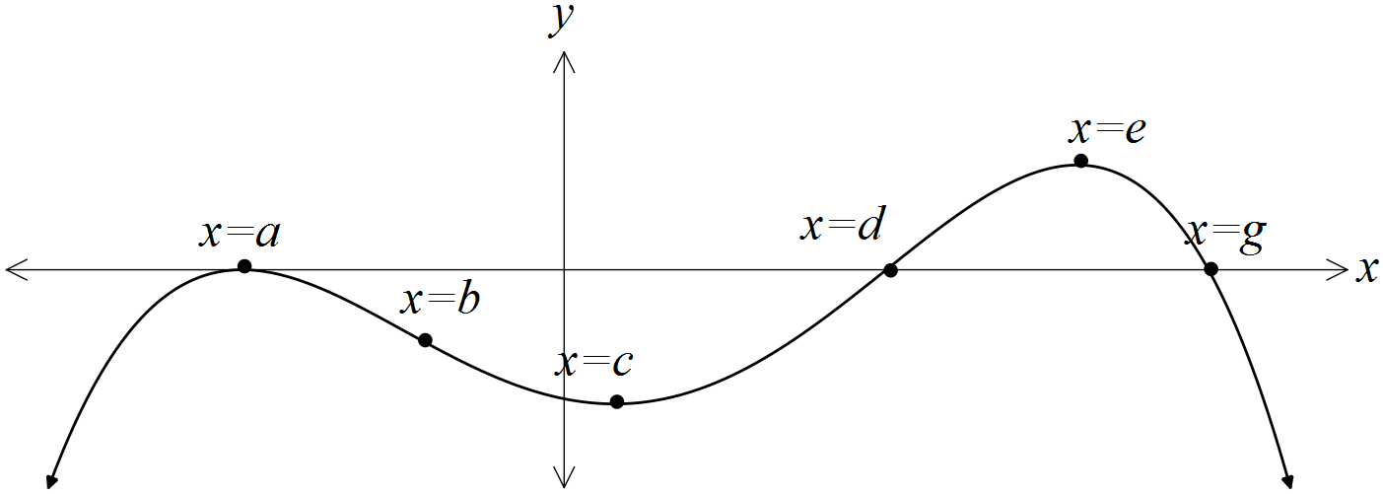

(a) For what value(s) of x does the graph of have a point of inflection? (1 mark)
Solution
Specific behaviours
states all three values

(b) Does the graph of have a local maximum? Justify your answer. (2 marks)
Solution
Yes, as x increases through , the gradient of f changes from positive to zero to negative, indicating a local maximum.
Specific behaviours
responds yes, indicating when
explains reason

(c) Does the graph of have a horizontal point of inflection? Justify your answer.
(2 marks)
Solution
Yes, as x increases through , the gradient of f changes from negative to zero to negative, indicating a horizontal pt of inflection.
Specific behaviours
responds yes, indicating when
explains reason

(d) On the axis below, sketch a possible graph of . The graph of is shown with a broken line for your reference. (3 marks)

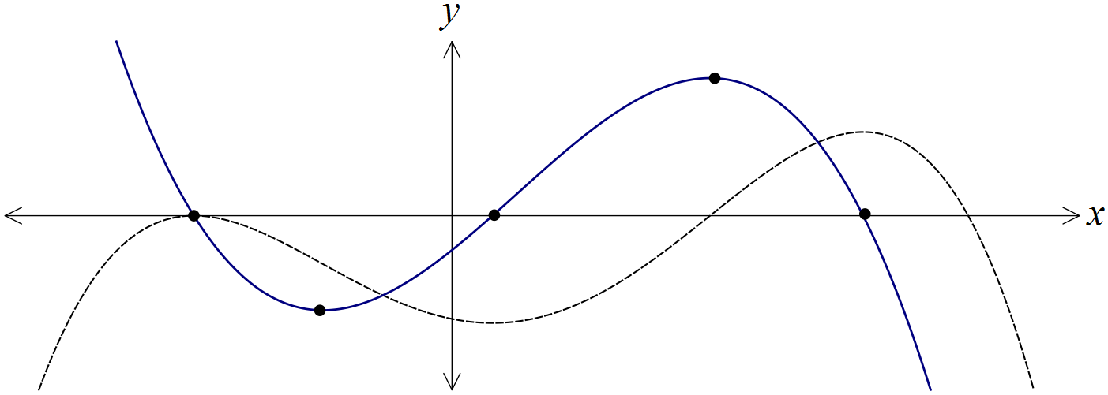
Solution
See graph
Specific behaviours
correctly aligns three roots with turning pts
correctly aligns min and max with pts of inflection
smooth curve through five key points

Question 18 (8 marks)
The graph of the function is shown below for .

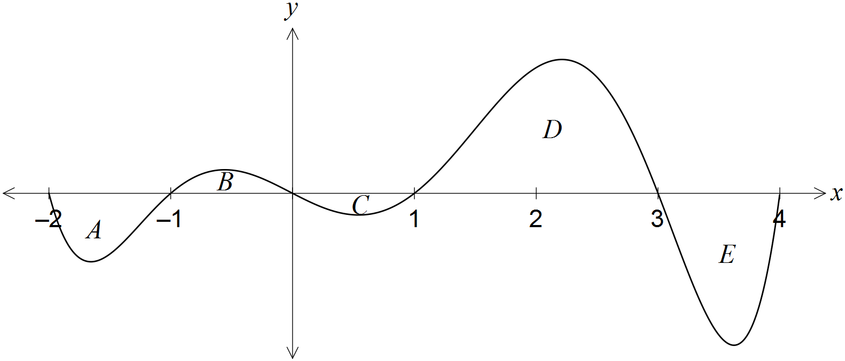

The area of regions enclosed by the x-axis and the curve, A, B, C, D and E, are 12, 7, 5, 32 and 21 square units respectively.

(a) Determine the value of . (2 marks)
Solution
Specific behaviours
assigns sign to all areas
adds signed values

(b) Determine the area of the region enclosed between the graph of and the x-axis from to . (2 marks)
Solution
Specific behaviours
chooses regions C, D and E
adds unsigned values

(c) Determine the values of

(i) . (2 marks)
Solution
Specific behaviours
splits integral into two parts
evaluates and sums each part

(ii) . (2 marks)
Solution
Specific behaviours
factors fraction out of integral
evaluates integral and halves

Question 19 (7 marks)
Three telecommunication towers, A, B and C, each need underground power cable connections directly to a new power station, P, that is to be built km from depot D on a 10 km road running east-west between D and A.

Tower B lies 4 km due north of depot D and tower C lies 7 km south of the depot, as shown in the diagram.

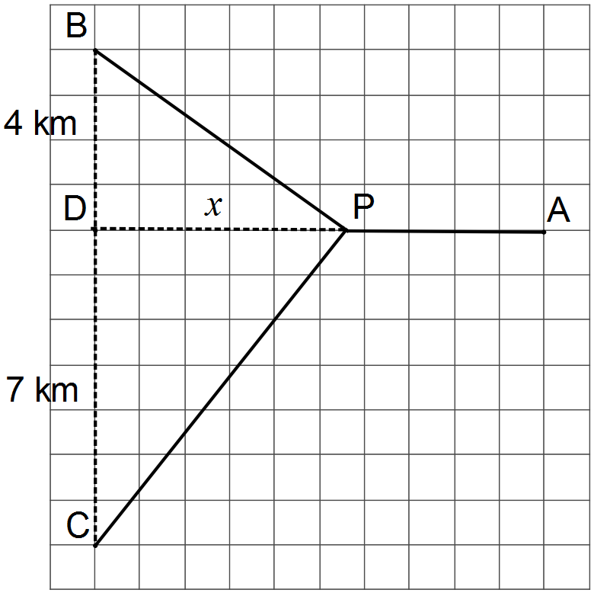

(a) Determine an expression for the total length of underground cable required to connect A, B and C directly to P. (2 marks)
Solution
Specific behaviours
uses Pythagoras' theorem for BP and CP
determines correct expression

(b) Show that the minimum length of cable occurs when . (3 marks)
Solution
Specific behaviours
uses chain rule to determine derivative
shows that derivative must equal zero
simplifies equation to required result

(c) Determine the minimum length of cable required, rounding your answer to the nearest hundred metres. (2 marks)
Solution
Specific behaviours
solves equation from (b)
substitutes to find length

Question 20 (7 marks)
Consider the function and the function .

(a) Complete the table below. (2 marks)

x | 0 | 1 | 2 | 3 | 4 | 5 | 6
 | 0 | -1.75 | -3 | -3.75 | -4 | -3.75 | -3
Solution
See table
Specific behaviours
calculates at least 3 correct values
calculates all values correctly

(b) For what value(s) of x is the function increasing? (1 mark)
Solution
Specific behaviours
correct inequality

(c) On the axes below, sketch the graph of for . (2 marks)

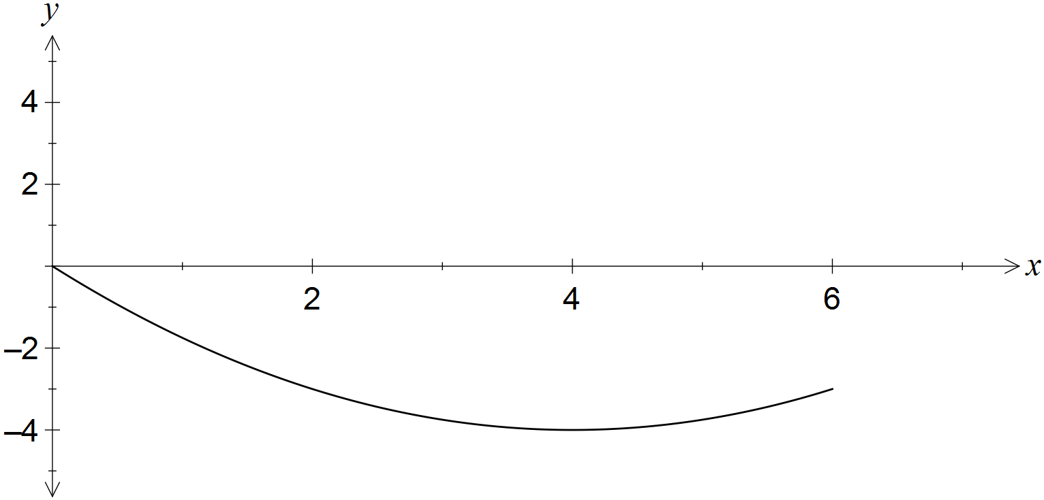
Solution
See graph
Specific behaviours
plots points from table
joins points in smooth curve

(d) Determine

(i) when . (1 mark)
Solution
Specific behaviours
states value

(ii) the function in terms of x. (1 mark)
Solution
Specific behaviours
states function in terms of x

Question 21 (7 marks)
A vertical wall, 2.1 metres tall, stands on level ground and 1.8 metres away from the wall of a house. A ladder, of negligible width, leans at an angle of to the ground and just touches the ground, wall and house, as shown in the diagram.

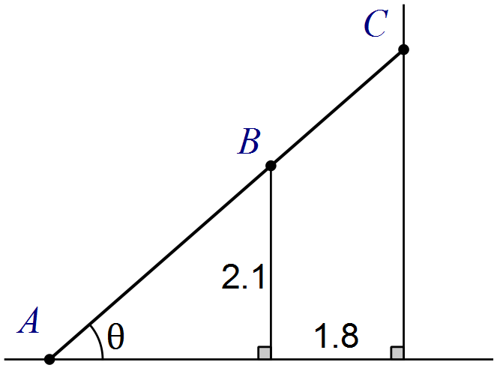

(a) Show that the length of the ladder, L, is given by . (3 marks)
Solution
Specific behaviours
shows on diagram and writes length of AB
shows on diagram and writes length of BC
sums lengths to obtain total, using labels added to diagram

(b) Use a calculus method to determine the length of the shortest ladder that can touch the ground, wall and house at the same time. (4 marks)
Solution
Specific behaviours
shows first derivative of L (may use CAS, but must show key results)
solves derivative equal to 0
obtains acute angle solution
substitutes into equation to obtain minimum length

Additional working space

Question number: _________

Additional working space

Question number: _________

